Sunday 7th January – Connect Group Notes

Standing at the Crossroads
Psalm 27
Jeremiah 6:16

Have you made any new year’s resolutions? If not, why don’t you?

Is life, and our world, ‘busier than ever’? Why do we feel this way?

Read Psalm 27
These are very confident words! Pick out all the ways we see this psalm express confidence and faith.

The psalmist is asking and seeking for ‘one thing’ (v4). What is it that he is seeking?
Can we still have this sort of focus to our lives today? How would we start to do this?

Read Jeremiah 6:13-20

Jeremiah is challenging the people for having turned away from God. He calls them to ‘stand at the crossroads and look’. As we begin a new year, what does ‘stand at the crossroads and look’ mean to you?

Jeremiah then calls the people to:
‘…ask for the ancient paths,
ask where the good way is, and walk in it’

What did this mean for those originally hearing Jeremiah’s words?
What does this mean for us today as followers of Jesus? (Andy linked this to Matthew 11:28-30)

What do both Jeremiah 6:16 and Matthew 11:28-30 promise us? How is this good news for us, and the world today?

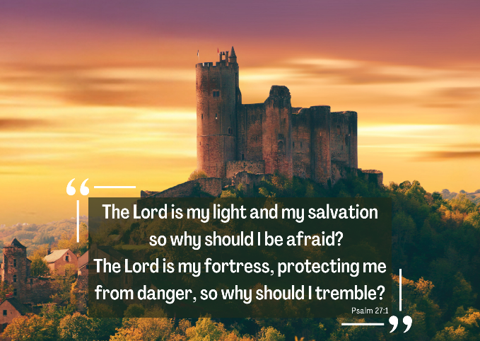
Our verse for the year is Psalm 27:1

We find the confidence and certainty of this verse, and the rest for our souls, as we focus our life on the ‘one thing’, in every part of our lives. Can you take some time as we begin this year to look at your life and seek God’s presence and path in every area?

Over the coming weeks we will be continuing to stand at the crossroads, as we follow a short ‘Spiritual MOT’ series reflecting on our love for God, each other and those who don’t know Jesus.

