Sunday 10th December – Connect Group Notes

Prince of Peace – The gift of Peace
Isaiah 9:2-7
Luke 23:32-43

Peace and Christmas – do the two go together?
- What about this time of year robs peace from your life?
- What helps you to know peace during this season?

In what ways do we often settle for an uneasy peace at Christmas, or more generally?

Read Isaiah 9:2-7

Jesus is the Prince of Peace – this is not an uneasy peace but the biblical understanding of ‘Shalom’, this carries a sense of a fullness, a wholeness, harmony, completeness, security and safety. To what extent do you think this is similar to what is secularly described as ‘well-being’ today?

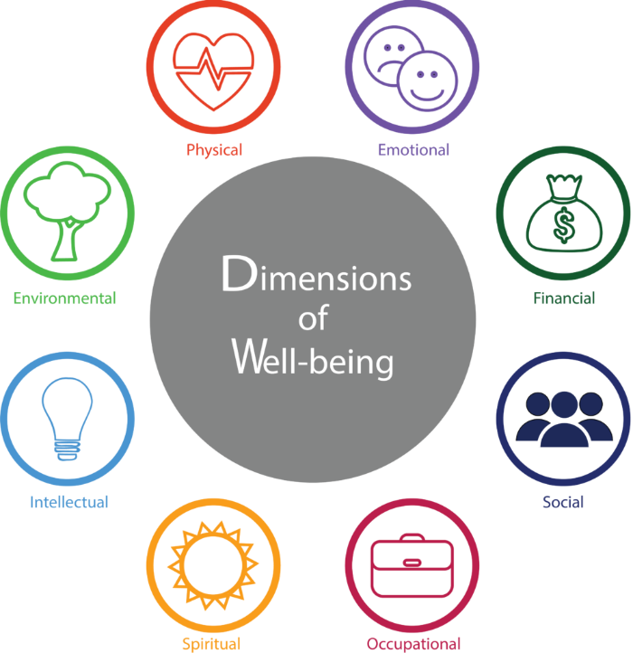
(There are many online examples of the idea of ‘well-being’, this one comes from https://www.wisconsin.edu/ohrwd/well-being/ where you can find more description of each area)

Rico Tice describes in his book that I want to live ‘my life by my rules’. What’s the relationship between our lack of peace – personally, in our relationships and in our world – and our desire to have things ‘my way’?

Read Luke 23:32-42

What stands out to you from this narrative?

What does this passage tell us about the two criminals who were executed with Jesus?
What does this passage tell us about God?
What does this passage teach us about ourselves?

Even facing death, one of the criminals executed with Jesus receives the gift of hope and peace through accepting he’d done wrong, acknowledging who Jesus is, and asking for His help. Returning to the idea of shalom and well-being – how can we find Peace in all the aspects of our lives, through placing Jesus at the centre?

Spend some time in prayer – that we would know peace, for those who don’t yet know the peace that Jesus offers and for the world as we await the return of the prince of peace.

